

**Otago Boys’ High School**

Website for a Client

**Assessment due date: Term 1, week 11 (12th April 5pm)**

**Credits: 4**

|  |  |  |
| --- | --- | --- |
| **Use complex techniques to develop a digital media outcome** | | |
| **Achievement** | **Achievement with Merit** | **Achievement with Excellence** |
| Use complex techniques to develop a digital media outcome. | Use complex techniques to develop an informed digital media outcome. | Use complex techniques to develop a refined digital media outcome. |

***Assessment Conditions: students can work collaboratively to discuss design ideas and give one another feedback. However, they must complete their coding independently. It is your job to prove authenticity of your final project. Your portfolio should clearly demonstrate the development of your project.***

**Use complex techniques to develop a digital media outcome (4 credits)**

**Use complex techniques to develop a digital media outcome involves:**

* applying appropriate tools and techniques to meet the purpose and end-user requirements
* applying appropriate data integrity and testing procedures
* applying user experience principles relevant to the purpose of the outcome
* addressing relevant implications.

**Use complex techniques to develop an informed digital media outcome involves:**

* using information from testing procedures to improve the quality of the digital media outcome
* applying user experience principles to improve the quality of the digital media outcome.

**Use complex techniques to develop a refined digital media outcome involves:**

* iterative improvement throughout the design, development and testing process to produce a high-quality outcome
* using efficient tools and techniques in the outcome’s production.

**Examples of *relevant implications* include:**

* social
* cultural
* legal
* ethical
* intellectual property
* privacy
* accessibility
* usability
* functionality
* aesthetics
* sustainability and future proofing
* end-user requirements
* health and safety.

Task Introduction

There are many things happening in our local community that would benefit from publicity and exposure on the internet. Perhaps a small business may need your help building a website to promote their services? or a teacher wants you to build a resource they could use to teach a topic in one of your classes.

You will create a multi-page website for a client promoting either a business, local community issue, or make an informative site on a topic of your choice. It is your job to source the client and content.

**Your final website must meet the following technical specifications:**

* sophisticated digital effects (CSS3)
* responsive design (mobile vs desktop)
* industry standards or guidelines for layout/design
* integration of original media types
* coded using HTML5/CSS3 language
* at least 3 html pages and an externally linked style sheet

**You must show evidence that you have trialled multiple components and/or techniques and have selected the ones that will work best for the outcome.**

**Your trialling should be done in an on-going, iterative manner.**

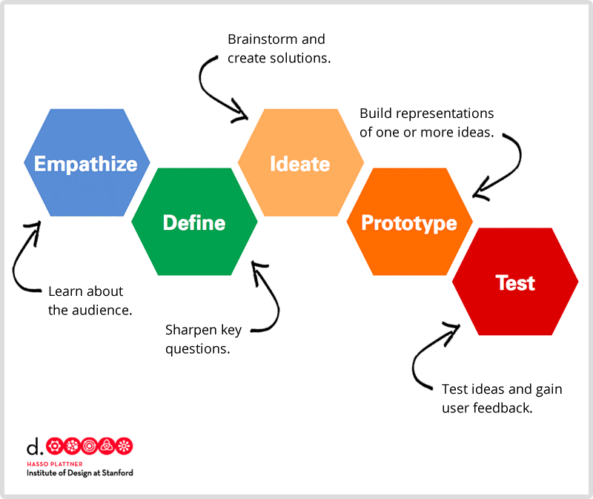

Step 1: Empathize (2 lessons)

* Identify your client, the target audience of your website
* Describe 3 relevant implications that you will be focusing on during the development of your site
* Meet with your client and record down their specifications

Step 2: Define (2 lesson)

* Sketch out the site structure
* Gain written permission for use of text / photographs
* Collect written content in a word document – proofread it
* Take photographs / edit images (compress and name appropriately)
* If need be, find stock photographs that are copyright free

Step 3: Ideate (2 lesson)

* Ideate colour palette and font options
* Create a low fidelity wireframe for all of your pages
* Create 2 different layout versions of your index page (A vs B testing)
* Get written feedback from client / end users
* Create a high fidelity mock up of your index - seek written feedback with your client. Does it meet the client’s needs?
* What changes do you need to make and why? Do you need to carry out further research or give more colour/font options etc/

Step 4: Protype / Testing (8 lessons)

* Set up your website folder
* Create your images folder and import your media assets
* Begin coding your site using HTML5/ CSS3
* Carry out A vs B testing to gather feedback on fonts/colours/layout etc
* Identify which usability principles you have applied to improve the quality of your design – screenshot your design, place in your portfolio and annotate and explain how it improved the usability, aesthetics or functionality etc.
* Test your site in different browsers
* Validate your code
* Add code comments that describe the code’s function/behaviour

Step 5: Iterative Improvement (ongoing)

**Ensure that you provided evidence of the following in your portfolio:**

* that the website has been trialled and tested regularly throughout the design and development phase
* that feedback from each cycle of trialling and testing has been used to improve the website
* how you applied user experience principles to improve the quality of the outcome
* efficient tools and techniques that you have used in the website’s production **(e.g. short-hand css properties, no unnecessary duplication of code, re-using classes etc**)

Step 6: Explain how your final design addressed the relevant implications (1 lesson)

* seek final written feedback from your client – has it meet their specs etc?
* This may include a discussion on how your website is:
  + is socially/culturally acceptable
  + honours legal, ethical and intellectual property obligations
  + considers any privacy issues
  + is accessible, usable and functional
  + is sustainable and future proof

.

Step 7: Final Submission:

* Submit your folder which contains your portfolio / website to 13DGT/DROPBOX